Locality Profile
Northern Locality
July 2020

Table of Contents
Summary Table 5
Notes for this profile: 8
Demographics 9
Summary: 9
Population 9
Figure 1: Population breakdown in Northern. 9
Figure 2: Population time trend and projection. 9
Figure 3: Change in population structure over the last five years. 10
Deprivation 10
Table 1: Percentage population living in the 2016 and 2020 SIMD Datazone Quintiles 10
Figure 4: Map of Data Zones within Northern coloured by SIMD quintiles. 11
Figure 5: Proportion of the population that reside in each 2020 SIMD quintile by domain. 11
Figure 6: Percentage population living in the 2016 and the 2020 SIMD and Domain Quintiles 12
Households 13
Summary: 13
Figure 7: Number of dwellings time trend. 13
Table 2: Breakdown of dwelling types by year for Northern locality. 14
Figure 8: Breakdown of households by council tax band for Northern in 2019. 14
Table 3: Percentage of households by council tax band for Northern in 2019. 14
Services 15
Figure 9: Map of GP practices by locality in East Ayrshire HSCP². 15
Table 4: Number of each type of service in Northern Locality². 15
General Health 16
Summary: 16
Life Expectancy 16
Figure 10: Average life expectancy in men and women over time. 16
Table 5: Average life expectancy in years for the latest time periods (2014-2018 aggregated years for the locality; 2016-2018 aggregated years for other areas). 17
Deaths, aged 15-44 18
Figure 11: Deaths aged 15-44 years by geographical area and over time. 18
Figure 12: Deaths at ages 15-44 in East Ayrshire HSCP localities. 18
Long-Term Physical Health Conditions and Multimorbidity 19
Figure 13: Multimorbidity of physical long-term conditions by age group in 2018/19. 19
Figure 14: Percentage people with each physical LTC, split by age group. 20
Table 6: Prevalence of the five most common physical LTCs as a percentage of the population across geographical areas (where 1 = most prevalent). 20
Cancer Registrations 21
Figure 15: Cancer registration rate over time and by geographical area. 21
Figure 16: Cancer registration rates in East Ayrshire HSCP localities. 21
Anxiety, Depression, and Psychosis Prescriptions 22
Figure 17: Percentage population prescribed ADP medication in East Ayrshire HSCP localities. 22
Figure 18: ADP prescriptions over time and by geographical area. 22
Lifestyle and Risk Factors 23
Summary: 23
Drug-related Hospital Admissions 23
Figure 19: Trend of Drug-related Hospital Admission Rates by geographical area. 23
Figure 20: Comparison of Drug-related Hospital Admission Rates for the period 2015/16 - 2017/18. 24
Alcohol-related Hospital Admissions 25
Figure 21: Trend of Alcohol-related Hospital Admission Rates by geographical area. 25
Figure 22: Comparison of Alcohol-related Hospital Admission Rates for 2018/19. 25
Alcohol-Specific Deaths 26
Figure 23: Trend of Alcohol-Specific Death Rates by geographical area. 26
Figure 24: Comparison of Alcohol-related Death Rates for the period 2014 - 2018 (5 year aggregate). 26
Bowel Screening Uptake 27
Figure 25: Trend of Bowel Screening Uptake for eligible men and women, by geographical area. 27
Figure 26: Comparison of Bowel Screening Uptake for 2016 - 2018. 28
Unscheduled Care 29
Emergency Admissions 30
Figure 27: Emergency admissions by age group 30
Figure 28: Emergency admissions by geographical area 30
Unscheduled Bed Days 31
Figure 29: Unscheduled bed days by age group 31
Figure 30: Unscheduled bed days by geographical area 31
A&E Attendances 32
Figure 31: A&E attendances by age group 32
Figure 32: A&E attendances by geographical area 32
Delayed Discharges 33
Figure 33: Delayed discharges by age group 33
Figure 34: Delayed discharges by geographical area 33
Emergency Admissions from a Fall 34
Figure 35: Falls by age group 34
Figure 36: Falls by geographical area 34
Emergency Readmissions (28 days) 35
Figure 37: Emergency readmissions by age group 35
Figure 38: Emergency readmissions by geographical area 35
Potentially Preventable Admissions (PPAs) 36
Figure 39: PPAs by age group 36
Figure 40: PPAs by geographical area 36
% Last 6 months in a Community Setting 37
Figure 41: Last 6 months in a community setting by geographical area 37
Unscheduled Care in Mental Health (MH) Hospitals 38
Emergency Admissions (MH) 39
Figure 42: MH Emergency admissions by age group 39
Figure 43: MH Emergency admissions by geographical area 39
Unscheduled Bed Days (MH) 40
Figure 44: MH Unscheduled bed days by age group 40
Figure 45: MH Unscheduled bed days by geographical area 40
Delayed Discharges (MH) 41
Figure 46: MH Delayed discharges by geographical area 41
Readmissions within 28 days (MH) 41
Figure 47: MH readmissions by geographical area 41
Footnotes 42
Appendices 43
Appendix 1: Indicator Definitions 43
Appendix 2: Conditions included as Potentially Preventable Admissions (PPAs) 46

Summary Table
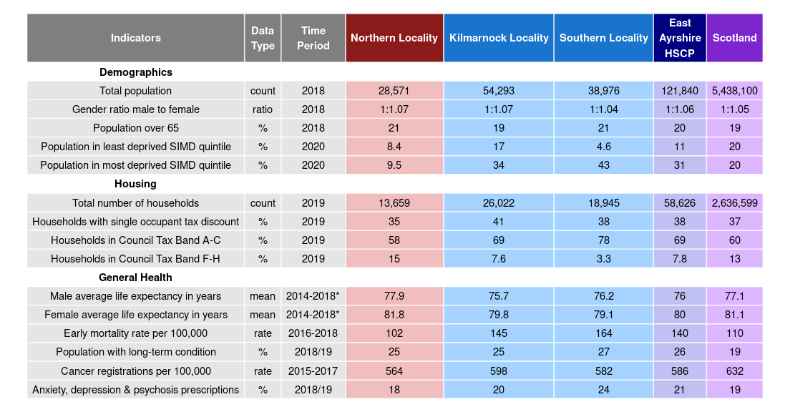

*At HSCP and Scotland level, the time period is a 3-year aggregate (2016-2018)

Page break
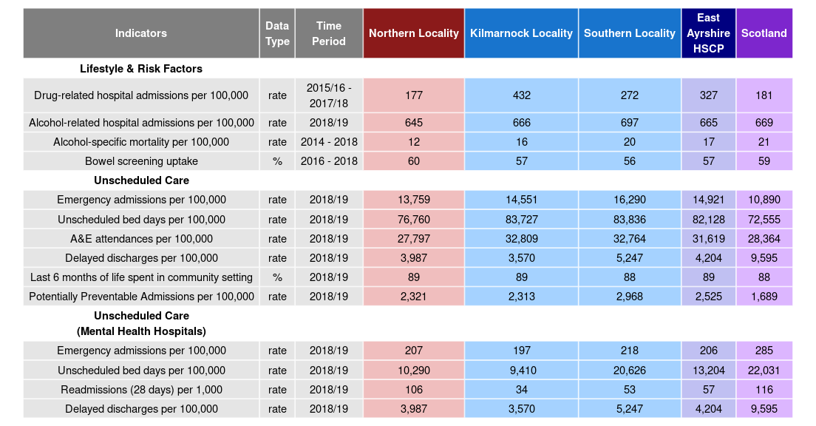

Page break

Notes for this profile:

- All years shown are calendar years unless otherwise specified.
- Upper and lower confidence intervals are shown throughout this document where available. In charts, these are displayed as shaded areas either side of trend lines, or as black error bars in bar charts. Confidence intervals show the range of possible values and a certainty that the true value falls within them.
- Definitions for the indicators shown are available in Appendix 1.

Page break

Demographics

Summary:
For the most recent time periods available, Northern Locality had:
- A total population of 28,571 people, where 48% were male, and 21% were aged over 65.
- 8.4% of people lived in the least deprived SIMD quintile, and 9.5% lived in the most deprived quintile.

Population
In 2018, the total population of Northern locality was 28,571. The graph below shows the population distribution of the locality.

Figure 1: Population breakdown in Northern.
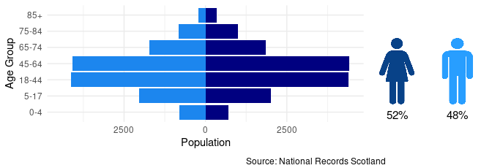
Figure 2 shows the historical population of Northern, along with the NRS population projections. The population has been rising. The population in Northern is estimated to decrease by 1.1% from 2018 to 2025. Please see the footnotes for more information on how the population projections were calculated¹.

Figure 2: Population time trend and projection.

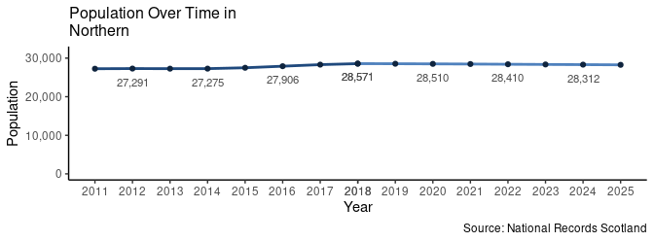

Page break
Figure 3 shows how population structure has changed between 2013 and 2018.

Figure 3: Change in population structure over the last five years.

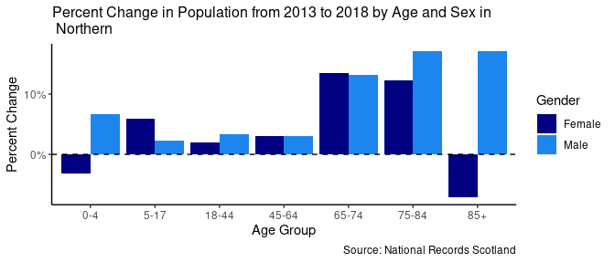

Deprivation
The following section explores the deprivation structure of Northern through the Scottish Index of Multiple Deprivation (SIMD). The SIMD ranks all datazones in Scotland by a number of factors; Access, Crime, Education, Employment, Health, Housing and Income. Based on these ranks, each datazone is then given an overall deprivation rank, which is used to split datazones into Deprivation Quintiles (Quintile 1 being the most deprived, and Quintile 5 the least). The most recent SIMD ranking was carried out in 2020. This section mainly focuses on the SIMD 2020 classifications, however the 2016 classifications are used to assess how deprivation has changed in Northern when compared to the rest of Scotland.
Of the 2018 population in Northern, 9.5% live in the most deprived SIMD Quintile, and 8.4% live in the least deprived SIMD Quintile. The following table details the percent of the population living in the 2016 SIMD Quintiles, the percent living in the 2020 SIMD Quintiles, and their difference for comparison.

Table 1: Percentage population living in the 2016 and 2020 SIMD Datazone Quintiles

Quintile | Percent of Pop (2016) | Percent of Pop (2020) | Difference
SIMD 1 | 12.7% | 9.5% | -3.2%
SIMD 2 | 27.1% | 25.7% | -1.3%
SIMD 3 | 24.0% | 26.4% | 2.4%
SIMD 4 | 24.2% | 29.9% | 5.7%
SIMD 5 | 12.1% | 8.4% | -3.6%

Figure 4: Map of Data Zones within Northern coloured by SIMD quintiles.
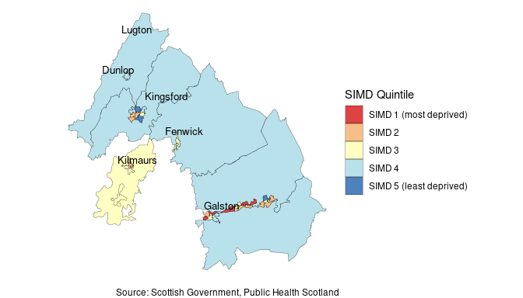

Figure 5: Proportion of the population that reside in each 2020 SIMD quintile by domain.

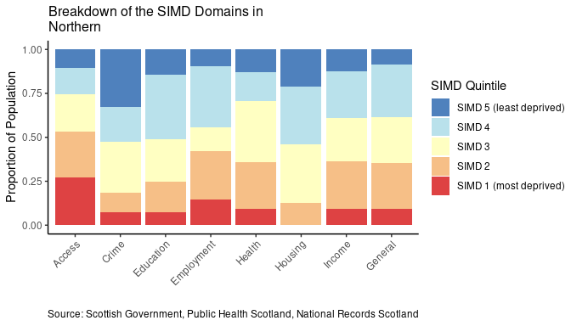

Page Break

Figure 6: Percentage population living in the 2016 and the 2020 SIMD and Domain Quintiles

Figure 6 presents a comparison between the 2016 Scottish Index of Multiple Deprivation figures, and the new 2020 SIMD figures. The percentages of the population living within each SIMD quintile and domain quintile were calculated first using the 2016 SIMD datazone classifications, and then the 2020 SIMD classifications. The differences in these percentages are plotted in Figure 6. Negative values on the y axis indicate a decrease in percent of the population living within a quintile, while positive values indicate an increase in percent of the population living within a quintile. Please note that quintiles have been weighted by the Scottish population so, any local changes in SIMD quintile do not necessarily indicate a difference in deprivation, but rather a difference in deprivation in comparison to the rest of Scotland.
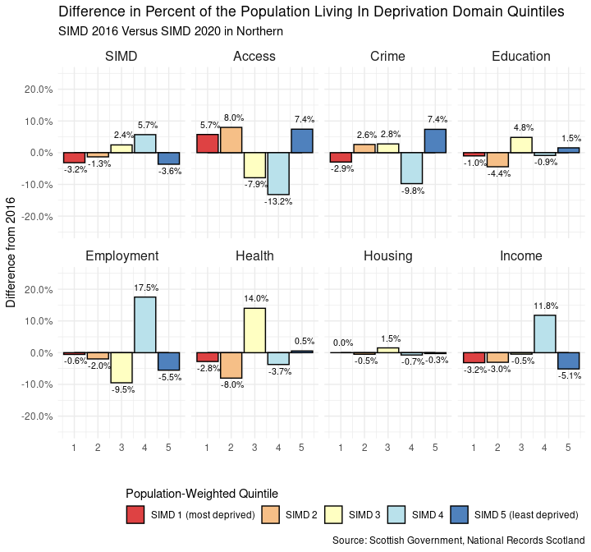

Page Break

Households

Summary:
For the most recent time periods available, Northern Locality had:
- 13,659 dwellings, of which: 96% were occupied and 0.25% were second homes.
- 35% of dwellers received a single occupant council tax discount, and 0.89% were exempt from council tax entirely.
- 58% of houses were within council tax bands A to C, and 15% were in bands F to H.

The graph below shows the number of dwellings in Northern from 2014 to 2019.

Figure 7: Number of dwellings time trend.

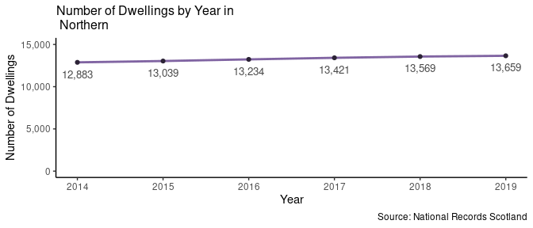
Of the total number of dwellings in 2019, 35% (4,714 households) were occupied by an individual receiving a single occupant council tax discount. Furthermore, 0.89% (122 households) were occupied and exempt from council tax.
There were 34 dwellings classed as a second home in 2019, these dwellings made up 0.25% of the households in Northern.

Page break

Table 2: Breakdown of dwelling types by year for Northern locality.

Year | Total Dwellings | Occupied Dwellings | Vacant Dwellings | Single Occupant Tax Discount | Council Tax Exempt Dwellings | Second Homes
2014 | 12,883 | 12,371 | 475 | 4,562 | 89 | 36
2015 | 13,039 | 12,527 | 478 | 4,612 | 95 | 33
2016 | 13,234 | 12,691 | 508 | 4,604 | 109 | 35
2017 | 13,421 | 12,832 | 550 | 4,665 | 101 | 38
2018 | 13,569 | 13,037 | 495 | 4,696 | 113 | 33
2019 | 13,659 | 13,158 | 467 | 4,714 | 122 | 34

The proportion of households within each council tax band are displayed in the chart below, figures are shown in Table 3.

Figure 8: Breakdown of households by council tax band for Northern in 2019.

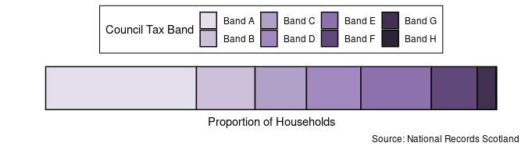

Table 3: Percentage of households by council tax band for Northern in 2019.

Tax Band | A | B | C | D | E | F | G | H
Percent of households | 33% | 13% | 11% | 12% | 16% | 10% | 4.1% | 0.2%

Pagebreak

Services

Figure 9: Map of GP practices by locality in East Ayrshire HSCP².

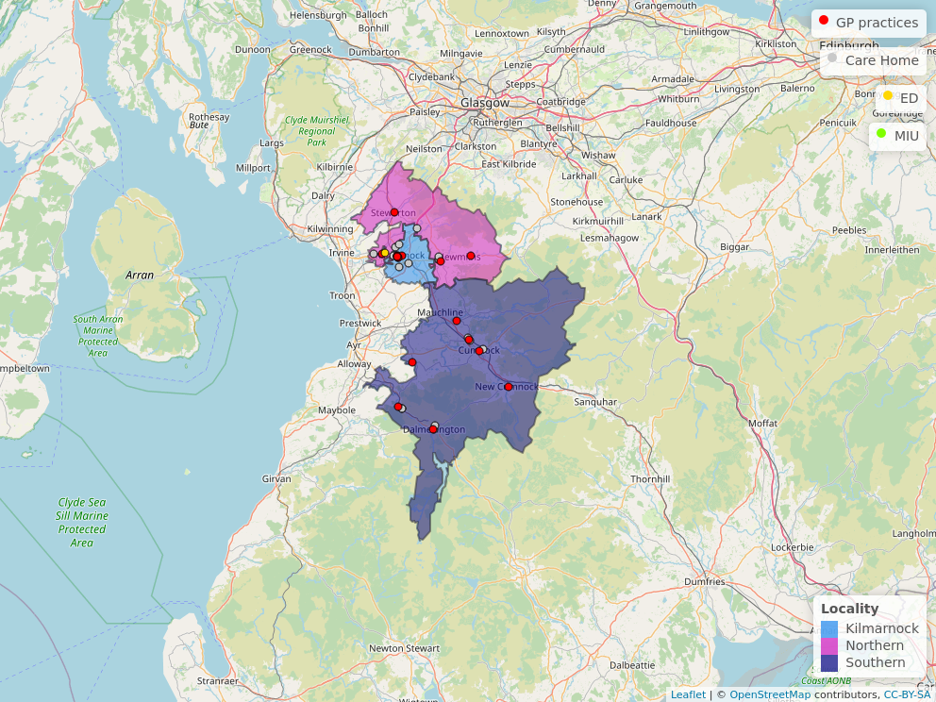

ED = Emergency Department, MIU = Minor Injuries Unit (or other)

Table 4: Number of each type of service in Northern Locality².

Service Type | Service | Number
Primary Care | GP Practice | 3
A&E | Emergency Department | 0
 | Minor Injuries Unit | 0
Care Home | Elderly Care | 4
 | Other | 4

Pagebreak

General Health

Summary:

For the most recent time periods available³, Northern Locality had:
- An average life expectancy of 77.9 years for males and 81.8 years for females.
- A death rate for ages 15 to 44 of 102 deaths per 100,000 age-sex standardised population⁴.
- 25% of the locality's population with at least one long-term physical health condition.
- A cancer registration rate of 564 registrations per 100,000 age-sex standardised population⁴
- 18% of the population being prescribed medication for anxiety, depression, or psychosis.

Life Expectancy
In the latest time period available from 2014-2018 (5 year aggregate), the average life expectancy in Northern locality was 77.9 years old for men, and 81.8 years old for women. A time trend since 2008-2012 can be seen in figure 10.

Figure 10: Average life expectancy in men and women over time.

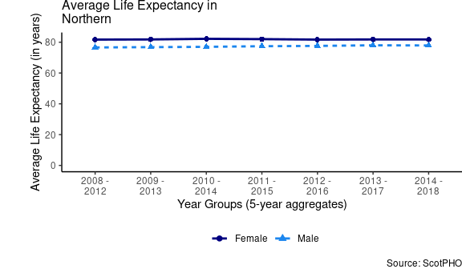

Page break
Table 5 provides the average life expectancy for men and women in different areas for the latest time period available. Please note that these are 5 year aggregates for the locality from 2014-2018, but 3 year aggregates from 2016-2018 at partnership, Health Board, and Scotland level.

Table 5: Average life expectancy in years for the latest time periods (2014-2018 aggregated years for the locality; 2016-2018 aggregated years for other areas).

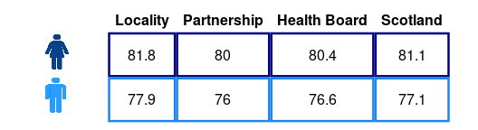

Where Locality = Northern, Partnership = East Ayrshire HSCP, Health Board = NHS Ayrshire & Arran.

Page break

Deaths, aged 15-44
The following chart shows a trend of death rates among 15-44 year olds per 100,000 age-sex standardised population⁴ by area (i.e. Early mortality rate per 100,000). In the most recent aggregate time period available (from 2016-2018), the mortality rate in Northern locality was 102 deaths per 100,000 population. Figure 12 then provides comparisons of deaths for all localities in East Ayrshire HSCP, for the two latest time aggregates available.

Figure 11: Deaths aged 15-44 years by geographical area and over time.

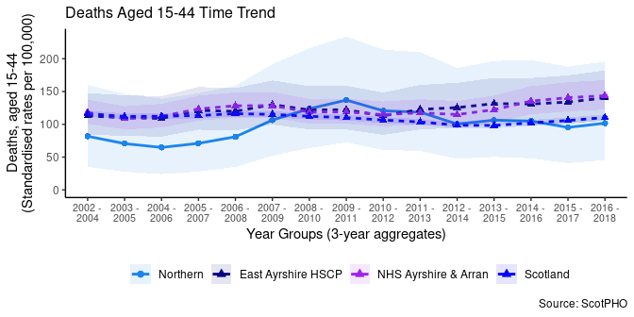

Figure 12: Deaths at ages 15-44 in East Ayrshire HSCP localities.

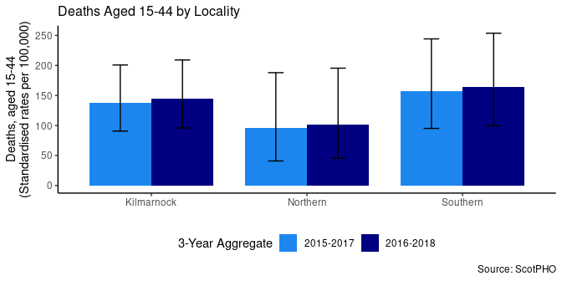

Page break

Long-Term Physical Health Conditions and Multimorbidity

In the financial year 2018/19, in Northern Locality, 25% of the total population had at least one physical long-term condition (LTC). These include: cardiovascular, neurodegenerative, and respiratory conditions, as well as other organ conditions (namely liver disease and renal failure), arthritis, cancer, diabetes, and epilepsy. Please see footnotes for information and caveats on identifying LTCs.⁵
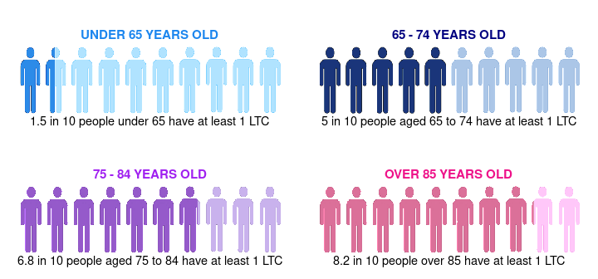
The co-occurrence of two or more conditions, known as multimorbidity, is broken down in figure 13, distinguishing between age groups. Note that this chart excludes the population in the locality who do not have any physical long-term conditions. Figure 13 therefore shows that among the people who have a LTC, 21% of those under the age of 65 have more than one, compared to 54% of those aged over 65.

Figure 13: Multimorbidity of physical long-term conditions by age group in 2018/19.

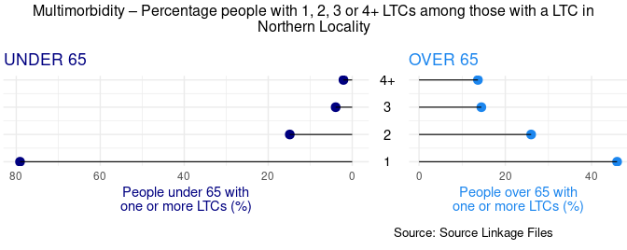

Page break
Most common physical Long-Term Conditions (LTCs)
Below is a breakdown of the physical LTCs, for the financial year 2018/19. Figure 14 shows the prevalence of different LTCs in each age group in Northern locality, and Table 6 illustrates the top 5 physical LTCs across all ages at locality, partnership, and Scotland level.

Figure 14: Percentage people with each physical LTC, split by age group.

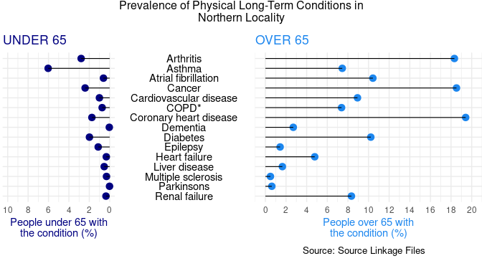

*COPD: Chronic Obstructive Pulmonary Disease

Table 6: Prevalence of the five most common physical LTCs as a percentage of the population across geographical areas (where 1 = most prevalent).

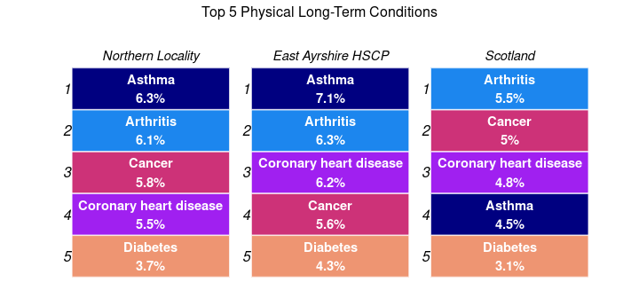

Cancer Registrations
For the period 2015-2017, there were 164 new cancer registrations per year on average (564 registrations per 100,000 age-sex standardised population) in Northern locality. This is a 8.3% decrease in cancer registrations rate from the previous aggregate period 2014-2016. Figure 15 shows changes over time since 2011-2013, and Figure 16 compares the rates of localities in East Ayrshire HSCP for the two latest available time periods.

Figure 15: Cancer registration rate over time and by geographical area.

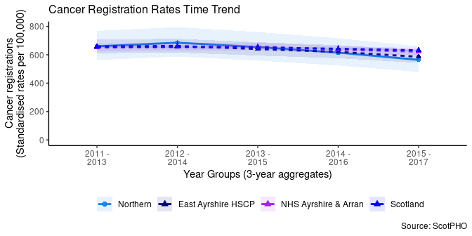

Figure 16: Cancer registration rates in East Ayrshire HSCP localities.

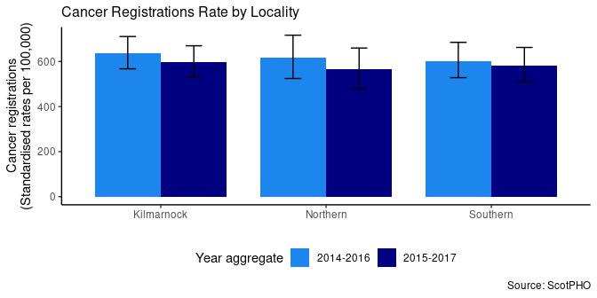

Page break

Anxiety, Depression, and Psychosis Prescriptions


In the 2018/19 financial year, 18% of people were prescribed medication for anxiety, depression, or psychosis (ADP) in Northern Locality. This is a 3% increase from the previous financial year.

Figure 17: Percentage population prescribed ADP medication in East Ayrshire HSCP localities.
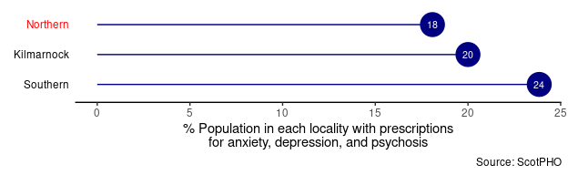

Figure 18: ADP prescriptions over time and by geographical area.

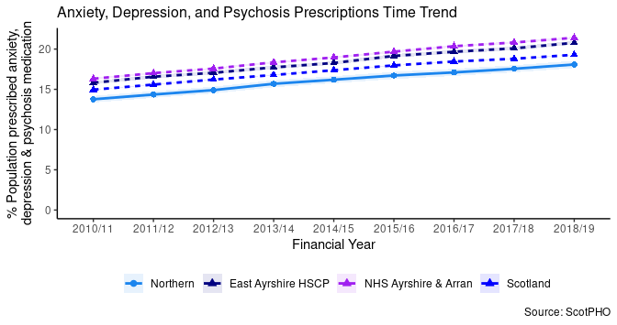

Pagebreak

Lifestyle and Risk Factors

Summary:

Mental and physical wellbeing has close ties with people’s lifestyles and behaviours. Financial security, employment and location are influences that often have a bearing on these choices. Issues can develop when alcohol, smoking or drug use shape lives. This section provides data on drug-related hospital admissions, alcohol-related hospital admissions, alcohol-specific mortality and bowel screening uptake, to give an overview of some of the lifestyles and behaviours for Northern locality. These can give an idea of quality of life and prosperity.

For the most recent time periods available³, Northern had:
- 177 drug-related hospital admissions per 100,000 age-sex standardised population⁴. This is a lower rate of admissions than for Scotland (181).
- 645 alcohol-related hospital admissions per 100,000 age-sex standardised population⁴.
- 12 alcohol-specific mortality per 100,000 age-sex standardised population⁴.
- a 60% uptake of bowel cancer screening for the eligible population.

Drug-related Hospital Admissions


There were 177 drug-related hospital admissions per 100,000 age-sex standardised population⁴ in Northern locality for the most recent time period available (3 year financial year aggregate for 2015/16 - 2017/18).
This is a -17% decrease since 2011/12 - 2013/14 (3 financial year aggregates).
A trend of the change in drug-related hospital admissions for Northern locality compared with Scotland, East Ayrshire HSCP and NHS Ayrshire & Arran is shown in the chart below from 2011/12 - 2013/14 onwards.

Figure 19: Trend of Drug-related Hospital Admission Rates by geographical area.

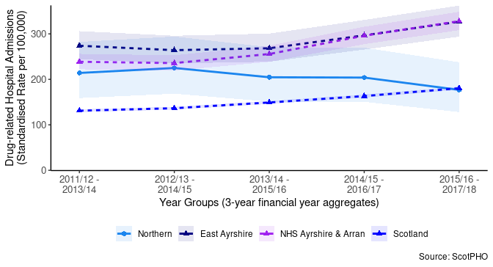
A comparison of areas at the most recent time period (2015/16 - 2017/18 aggregated financial years) is available below. This shows Northern locality has a lower rate of admissions (177) than East Ayrshire Partnership (327), and a lower rate of admissions than Scotland (181) overall.

Figure 20: Comparison of Drug-related Hospital Admission Rates for the period 2015/16 - 2017/18.

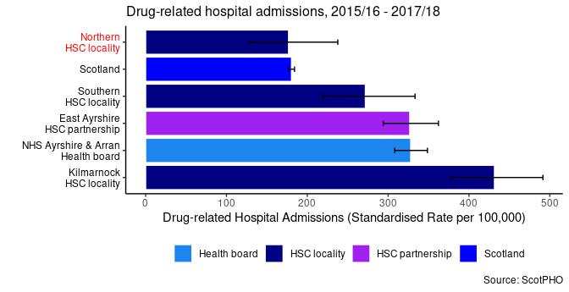

Page Break

Alcohol-related Hospital Admissions


The 2018/19 alcohol-related admissions rate is 645 per 100,000 age-sex standardised population⁴, which is a 13% decrease overall since 2011/12.
The chart below shows a trend of alcohol-related hospital admissions for Northern locality compared with Scotland, East Ayrshire Partnership and NHS Ayrshire & Arran from financial year 2011/12 to 2018/19.

Figure 21: Trend of Alcohol-related Hospital Admission Rates by geographical area.

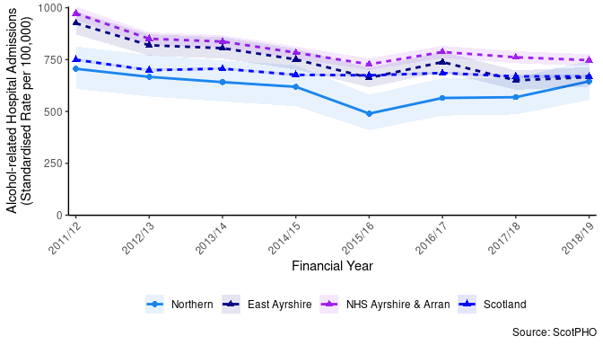

Comparison across different areas for 2018/19 is shown in Figure 22. This shows that Northern locality had a lower alcohol-related hospital admissions rate (645) compared to Scotland (669).

Figure 22: Comparison of Alcohol-related Hospital Admission Rates for 2018/19.

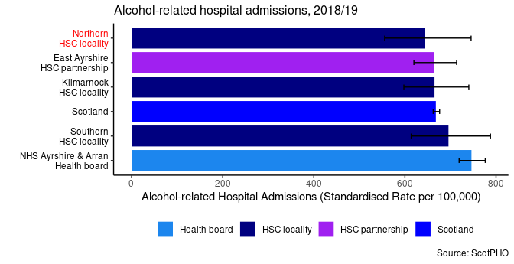

Alcohol-Specific Deaths
Data on alcohol-specific deaths is available as 5 year aggregates. The rate of alcohol-specific deaths is currently lower in Northern than the rate in 2009 - 2013 (-3.9% change).

Figure 23: Trend of Alcohol-Specific Death Rates by geographical area.

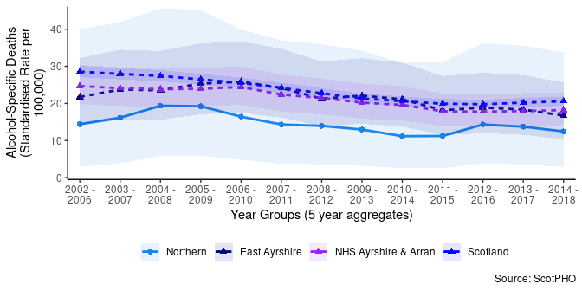
A comparison across different areas illustrates that Northern locality has a lower alcohol-specific death rate compared to Scotland as a whole.

Figure 24: Comparison of Alcohol-related Death Rates for the period 2014 - 2018 (5 year aggregate).

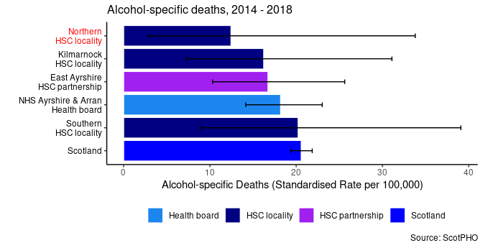

Bowel Screening Uptake
Bowel screening is offered every two years to eligible men and women aged between 50-74 years old. Eligible people are posted a test kit which is completed at home. Since 1st April 2013, those aged 75 and over can also self-refer and opt into screening.
A trend of the percentage uptake of bowel screening among the eligible population is shown below for Northern locality compared with Scotland, East Ayrshire HSCP and NHS Ayrshire & Arran. Data is suppressed into 3 year aggregates. The 2016 - 2018 uptake rate for Northern is 60%.

Figure 25: Trend of Bowel Screening Uptake for eligible men and women, by geographical area.

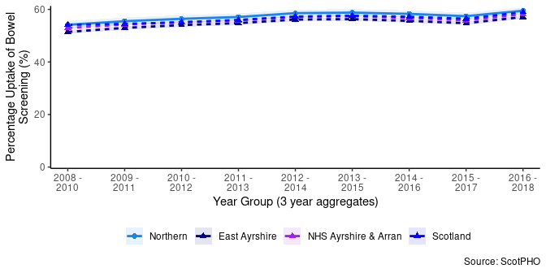
Compared with Scotland, Northern locality has a higher percentage uptake of bowel cancer screening for the period 2016 - 2018.

Figure 26: Comparison of Bowel Screening Uptake for 2016 - 2018.

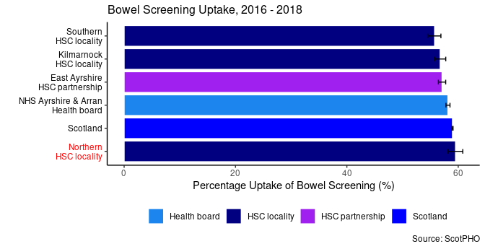

Pagebreak

Unscheduled Care
This section includes acute and mental health acute hospital data, delayed discharges and A&E attendances.
For the most recent time periods available, Northern had:
- 13,759 emergency health hospital admissions per 100,000 population.
- 76,760 unscheduled hospital bed days per 100,000 population.
- 27,797 A&E attendances per 100,000 population.
- 3,987 delayed discharges per 100,000 population.
- 704 falls admissions per 100,000 population.
- 113 readmissions (28 day) per 1,000 discharges.
- 2,321 potentially preventable hospital admissions per 100,000 population.
- 89% of people spent their last 6 months of life in a community setting.

Pagebreak

Emergency Admissions

Figure 27: Emergency admissions by age group

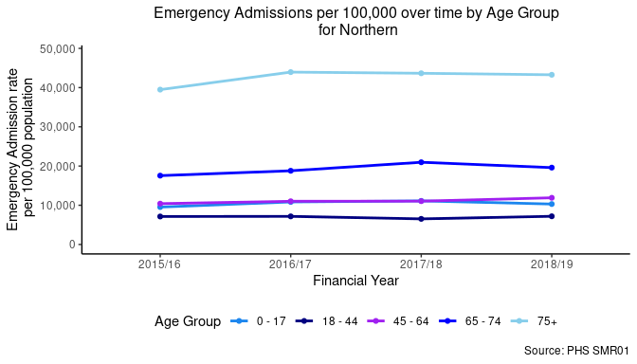

Figure 28: Emergency admissions by geographical area

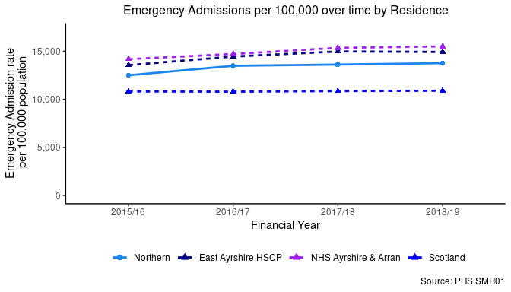

Unscheduled Bed Days

Figure 29: Unscheduled bed days by age group

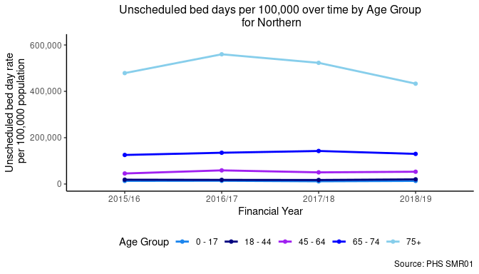

Figure 30: Unscheduled bed days by geographical area

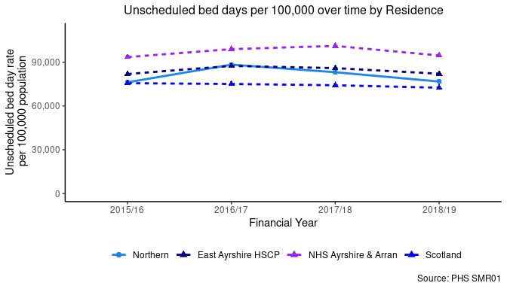

A&E Attendances

Figure 31: A&E attendances by age group

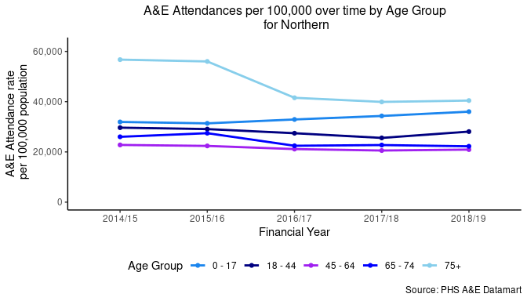

Figure 32: A&E attendances by geographical area

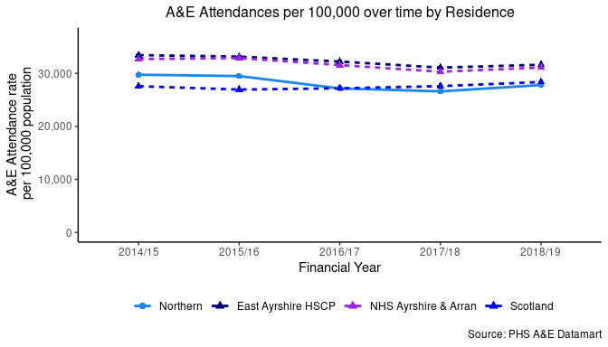

Delayed Discharges

Figure 33: Delayed discharges by age group

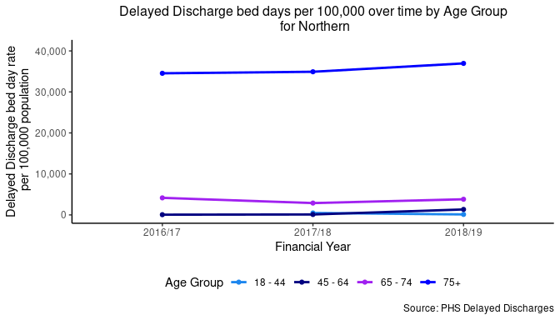

Figure 34: Delayed discharges by geographical area

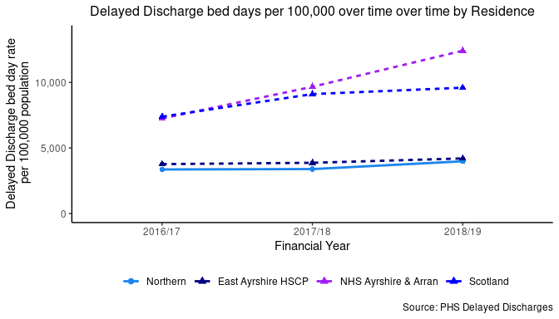

Emergency Admissions from a Fall

Figure 35: Falls by age group

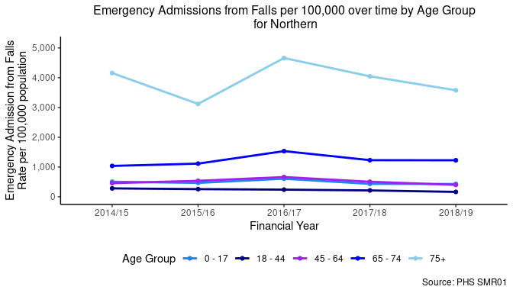

Figure 36: Falls by geographical area

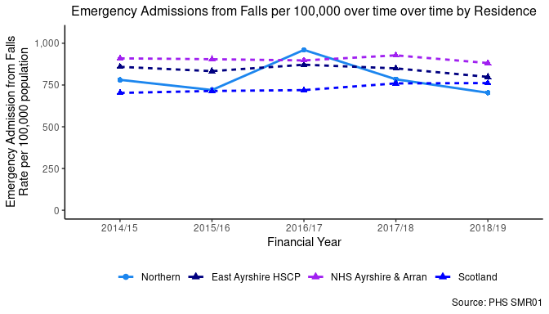

Emergency Readmissions (28 days)

Figure 37: Emergency readmissions by age group

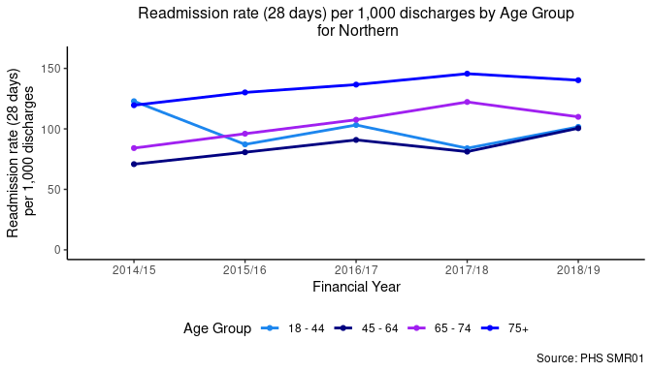

Figure 38: Emergency readmissions by geographical area

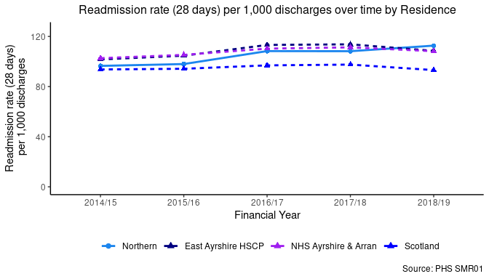

Potentially Preventable Admissions (PPAs)
Information on which conditions are counted as PPAs is available in Appendix 2.

Figure 39: PPAs by age group

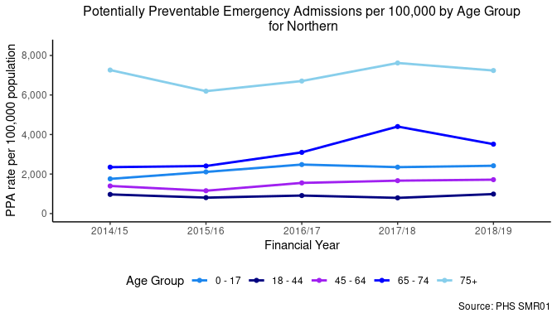

Figure 40: PPAs by geographical area

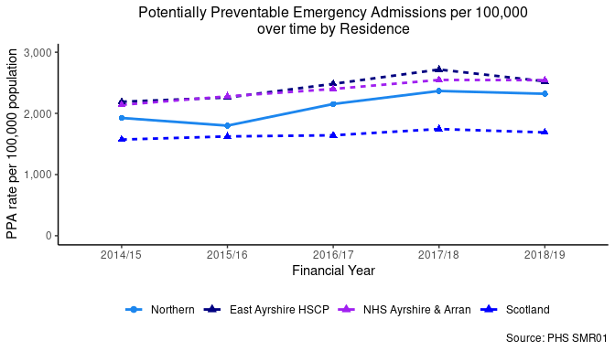

% Last 6 months in a Community Setting

Figure 41: Last 6 months in a community setting by geographical area

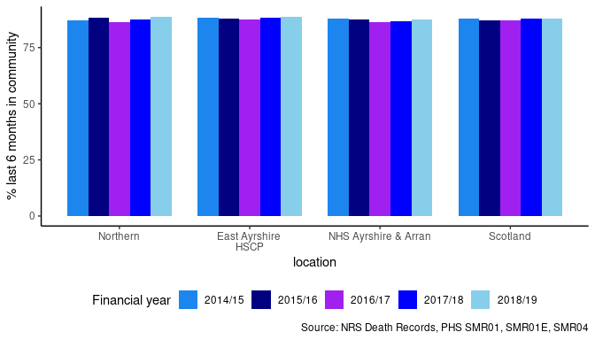

Pagebreak

Unscheduled Care in Mental Health (MH) Hospitals
This section looks at hospital admissions to mental health specialties.
For the most recent time periods available, Northern had:
- 207 emergency mental health hospital admissions per 100,000.
- 10,290 unscheduled mental health hospital bed days per 100,000.
- 3,987 delayed discharges per 100,000.
- 106 readmissions (28 day) per 1,000.

Pagebreak

Emergency Admissions (MH)

Figure 42: MH Emergency admissions by age group

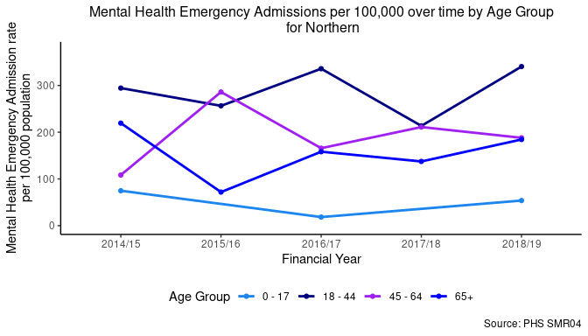

Figure 43: MH Emergency admissions by geographical area

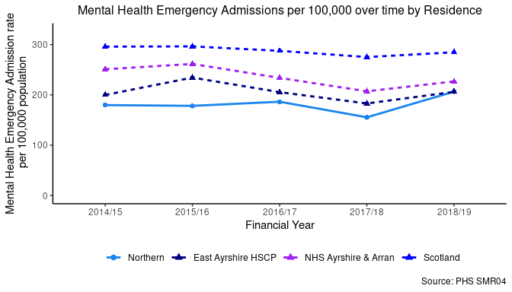

Unscheduled Bed Days (MH)

Figure 44: MH Unscheduled bed days by age group

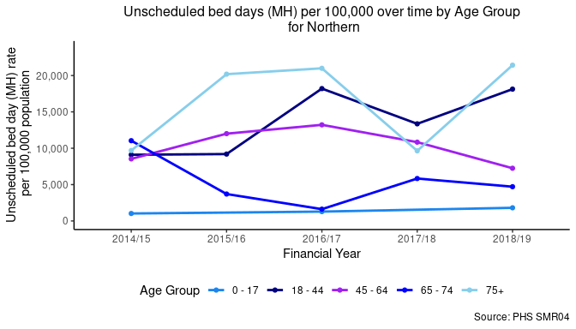

Figure 45: MH Unscheduled bed days by geographical area

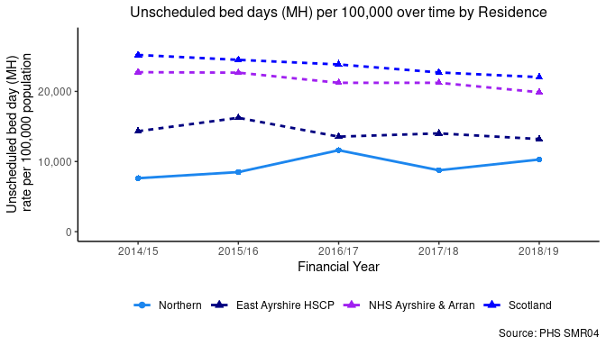

Delayed Discharges (MH)

Figure 46: MH Delayed discharges by geographical area

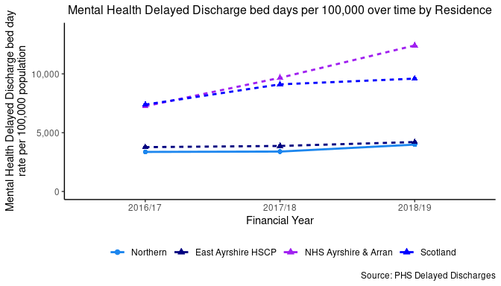

Readmissions within 28 days (MH)

Figure 47: MH readmissions by geographical area

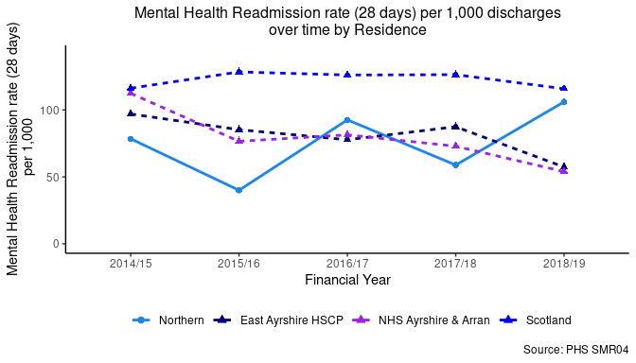

Page Break

Footnotes
- Population projections are not currently provided by NRS at the locality level. To explore how the population in Northern is expected to change in the future, the percent changes in population projection to 2025 for East Ayrshire by age group and gender were calculated from the NRS Local Authority Population Projections. These percent changes were then applied to the Northern 2018 mid-year population estimates (also split by age group and gender) to obtain population projection estimates for Northern, based on the projections for the HSCP and the current population structure of the locality.
- Care Home Data included in the Services Map and Table was sourced from the Care Inspectorate. GP Practice data from April 2020, and Hospital and A&E data was sourced from Public Health Scotland Open Data. Only services that are within the physical boundary of the HSCP or Locality are included in the map and table, so there may be services outside East Ayrshire which people may use but are not shown.
- The data used in General Health and Lifestyle & Risk factors sections (except for long-term conditions) of this locality profile are taken from ScotPHO. There may be more recent data available for the indicators elsewhere.
- Data taken from ScotPHO is often reported using the European Age-Sex Standardised Rate per 100,000. This allows for comparisons across different areas to be made. For more information on how these rates are calculated, please refer to www.isdscotland.org/Products-and-Services/GPD-Support/Population/Standard-Populations/
- Physical long-term conditions data comes from the Source Linkage Files, and the conditions are identified using ICD-9 and ICD-10 codes in the diagnosis fields. Please note that the Source Linkage Files data only contains information on people who have had contact with the NHS through either inpatient admissions, outpatient attendances, daycase attendances, A&E attendances or through prescribed items, the data does not show all service users in Scotland who have been diagnosed with an LTC as not all of these individuals will have used these services. Also note that LTC rates are based on an adjusted population indicator in the Source Linkage Files so that population sizes are closer to the official estimates.

Page Break

Appendices

Appendix 1: Indicator Definitions

Indicator | Definition
% last 6 months of Life Spent in a Community Setting | The percentage of time spent by people in their last 6 months of life in the community. Community includes care home residents as well as those living in their own home. Considers all hospital activity (e.g. geriatric long stay (GLS), mental health, acute). Inpatient activity with a care home location code recorded in SMR is included within the Community percentage for all years presented. This activity represents beds funded by the NHS which are located within a care home.
A&E Attendances | Attendance rates to A&E departments for patients by residence per 100,000 population. Includes all ages.
Alcohol-related hospital admissions | General acute inpatient and day case stays with diagnosis of alcohol misuse in any diagnostic position (ICD-10 code: E24.4, E51.2, F10, G31.2, G62.1, G72.1, I42.6, K29.2, K70, K85.2, K86.0, O35.4, P04.3, Q86.0, R78.0, T51.0, T51.1, T51.9, X45, X65, Y15, Y57.3, Y90, Y91, Z50.2, Z71.4, Z72.1). All rates have been standardised against the European standard population (ESP2013) and 2011-based population estimates.
Alcohol-specific deaths | Alcohol related deaths (based on new National Statistics definition): 5-year rolling average number and directly age-sex standardised rate per 100,000 population. (ICD-10 codes from the primary cause of death: E24.4,F10,G31.2,G62.1,G72.1,I42.6,K29.2,K70,K85.2,K86.0,Q86.0,R78.0,X45,X65,Y15).
Bowel Screening Uptake | Bowel screening uptake for all eligible men and women invited (aged 50-74): 3-year rolling average number percentage. Eligible men and women are posted a guaiac-based faecal occult blood test kit (FOBT) which should be completed at home. This involves collecting 2 samples from each of 3 separate bowel movements. The kit is returned in a pre paid envelope to the central screening centre in Dundee and tested for hidden traces of blood in the stool. Individuals who have a positive FOBT result are referred to their local hospital for assessment and, where appropriate, offered a colonoscopy as the first line of investigation.
Cancer Registrations | New cancer registrations: 3 year rolling average number and directly age-sex standardised rate per 100,000 population. All rates have been standardised against the European standard population (ESP2013) and 2011-base population estimates. ICD10: C00-C96 excluding C44 (principal diagnosis only).
Death, aged 15-44 | Deaths from all causes (ages 15-44 years), 3 year rolling average number and directly age sex standardised rate per 100,000 population. All rates have been standardised against the European standard population (ESP2013). Deaths assigned to year based on death registration date.
Delayed Discharges | Number of days people aged over 18 spend in hospital when they are ready to be discharged per 100,000 population. This has been separated into two indicators – one for acute specialty and one for mental health specialty stays.
Drug-related hospital admissions | General acute inpatient and day case stays with diagnosis of drug misuse in any diagnostic position (ICD10: F11-F16, F18, F19, T40.0-T40.9), 3-year rolling average number and directly age-sex standardised rate per 100,000 population. All rates have been standardised against the European standard population (ESP2013) and 2011-based population estimates.
Emergency Admissions | Rate of acute emergency (non-elective) admissions of patients of all ages per 100,000 population. This has been separated into two indicators – one for acute specialty and one for mental health specialty stays.
Fall Admissions | Rates of emergency admissions (non-elective) of patients of all ages where a fall has been logged as an ICD-10 code (searched for in all diagnostic positions) – acute specialties only.
Life expectancy, females | Estimated female life expectancy at birth in years, multi-year average (over 3 years for NHS Boards and Local Authorities, 5 years for Intermediate zones) Mortality data are based on year of registration. They also include non-Scottish residence so the number of deaths match those produced by NRS.
Life Expectancy, males | Estimated male life expectancy at birth in years, multi-year average (over 3 years for NHS Boards and Local Authorities, 5 years for Intermediate zones) Mortality data are based on year of registration. They also include non-Scottish residence so the number of deaths match those produced by NRS.
Physical Long-Term Conditions | Health conditions that last a year or longer, impact a person's life, and may require ongoing care and support. The LTCs presented are: Arthritis, Atrial Fibrillation, Cancer, Coronary Heart Disease, Chronic Obstructive Pulmonary Disease (COPD), Cerebrovascular Disease, Dementia, Diabetes, Epilepsy, Heart Failure, Liver Failure, Multiple Sclerosis, Parkinson's, and Renal Failure.
Population prescribed drugs for anxiety/depression/psychosis | Estimated number and percentage of population being prescribed drugs for anxiety, depression or psychosis.
Potentially Preventable Admissions (PPA) | Emergency admissions (non-elective) of patients of all ages where specific diagnoses are assigned as preventative - please see complete list of ICD-10 codes included in Appendix 2.
Readmissions (28 day) | The rate of readmissions of all adults (18+) within 28 days of an emergency admission per 1,000 discharges. This has been separated into two indicators – one for acute specialty and one for mental health specialty stays.
Unscheduled Bed days | Rate of acute unscheduled bed days of patients of all ages per 100,000 population. Takes the bed days spent only within the year of measurement – stays that overlap financial years will have their respective days counted either side. This has been separated into two indicators – one for acute speciality and one for mental health specialty stays.
Unscheduled Care in Mental Health Hospitals | Mental health admission data is taken from SMR04, which holds records on patients receiving inpatient care in mental health (psychiatric) facilities. Episodes beginning with a transfer have also been included in these figures, as well as emergency admissions as many of these episodes will have started as unplanned acute admission. Therefore the initial unscheduled admission need not have been to a mental health long stay speciality.

Page Break

Appendix 2: Conditions included as Potentially Preventable Admissions (PPAs)
Condition | ICD10 codes included | Comments
Ear Nose And Throat | H66, J028, J029, J038, J039, J06, J321 | NA
Dental | K02, K03, K04, K05, K06, K08 | NA
Convulsions And Epilepsy | G40, G41, R56, O15 | NA
Gangrene | R02 | NA
Nutritional Deficiencies | E40, E41, E43, E550, E643, M833 | NA
Dehydration And Gastroenteritis | E86, K522, K528, K529 | NA
Pyelonephritis | N10, N11, N12 | NA
Perforated Bleeding Ulcer | K250, K251, K252, K254, K255, K256, K260, K261, K262, K264, K265, K266, K270, K271, K272, K274, K275, K276, K280, K281, K282, K284, K285, K286 | Excludes episodes with following main OPCS4 codes: S06, S57, S68, S70, W90, X11
Cellulitis | L03, L04, L080, L088, L089, L980 | NA
Pelvic Inflammatory Disease | N70, N73 | NA
Influenza And Pneumonia | J10, J11, J13, J181 | NA
Other Vaccine Preventable | A35, A36, A370, A379, A80, B05, B06, B161, B169, B26 | NA
Iron Deficiency | D501, D508, D509 | NA
Asthma | J45, J46 | NA
Diabetes Complications | E100, E101, E102, E103, E104, E105, E106, E107, E108, E110, E111, E112, E113, E114, E115, E116, E117, E118, E120, E121, E122, E123, E124, E125, E126, E127, E128, E130, E131, E132, E133, E134, E135, E136, E137, E138, E140, E141, E142, E143, E144, E145, E146, E147, E148 | NA
Hypertension | I10, I119 | Exclude episodes with following main OPCS4 codes: K01 - K50, K56, K60 - K61
Angina | I20 | Exclude episodes with main OPCS4 codes: K40, K45 K49, K60, K65, K66
COPD | J20, J41, J42, J43, J44, J47 | J20 only included if secondary diagnosis has one of J41 - J44, J47
Congestive Heart Failure | I110, I50, J81 | Exclude episodes with following main OPCS4 codes: K01 - K50, K56, K60 - K61

